Lab Experiments
SET -4
S. V. K. Sharon Surya
192324246

1.
# Read Dataset
inventory <- read.csv("C:\\Users\\svkss\\Documents\\DHV files\\lab exps\\Product_ID,Product_Name,Category,Qu.csv")

# Bar Chart
barplot(inventory$Quantity_Available,
names.arg=inventory$Product_Name,
col="skyblue",
main="Product Inventory Quantity",
xlab="Products",
ylab="Quantity Available")
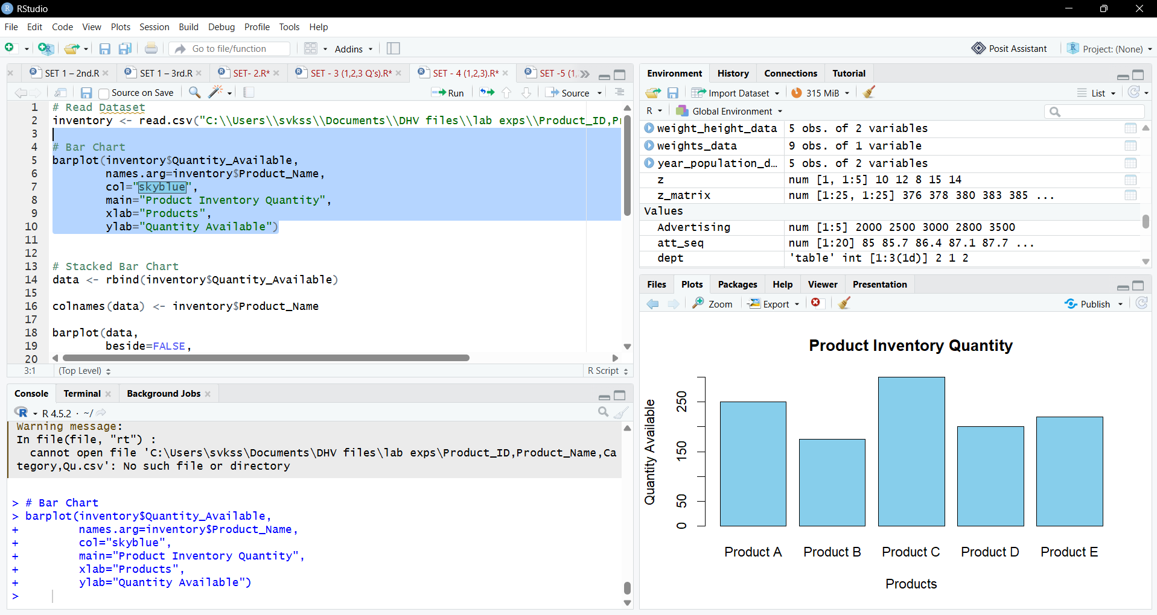

2.
# Stacked Bar Chart
data <- rbind(inventory$Quantity_Available)

colnames(data) <- inventory$Product_Name

barplot(data,
beside=FALSE,
col=rainbow(5),
names.arg="Inventory",
legend.text=inventory$Product_Name,
main="Product Quantities by Category")
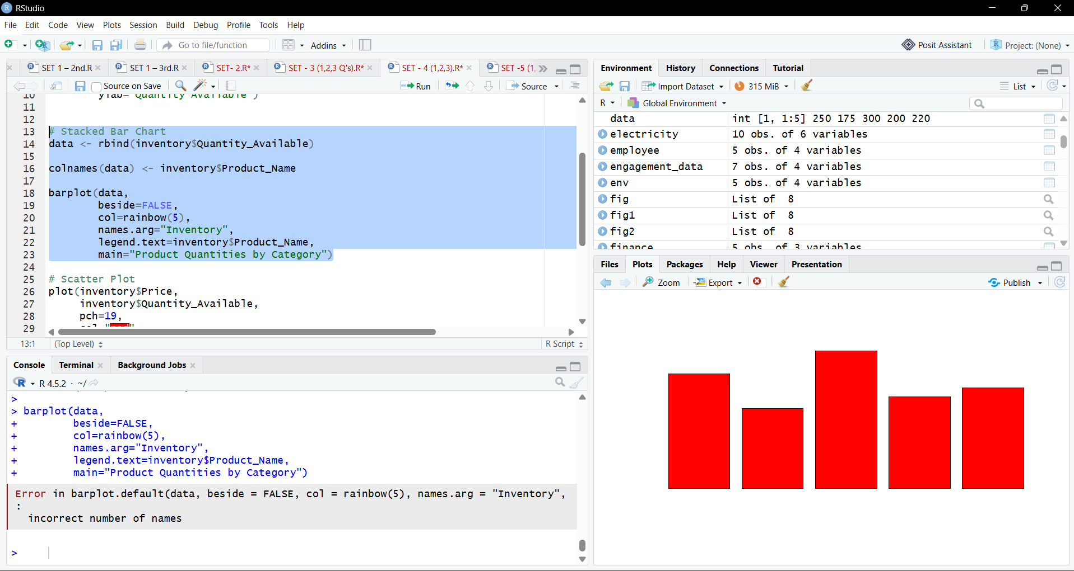

3.
# Scatter Plot
plot(inventory$Price,
inventory$Quantity_Available,
pch=19,
col="red",
main="Price vs Quantity Available",
xlab="Price (₹)",
ylab="Quantity Available")

abline(lm(Quantity_Available~Price,
data=inventory),
col="blue",
lwd=2)

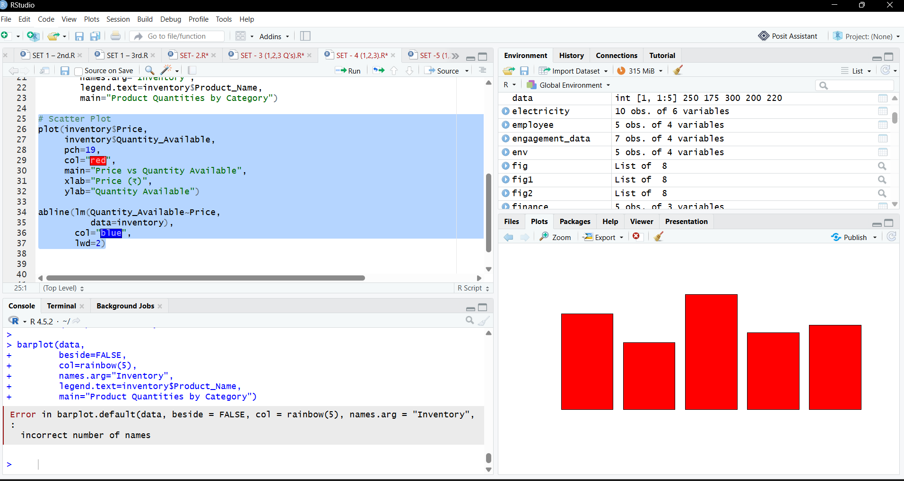

4.
